

**FASHION APPAREL GENERATION**

**NACHIKETH DORAISWAMY** (A0215523N)

**LAKSHMI SUBRAMANIAN** (A0215255L)

**YALAVARTI DHARMA TEJA** (A0215457A)

TABLE OF CONTENTS

REQUIREMENTS

System Overview

Recommended Browsers

Tech stack

Installation Guide

Back-end

Frond-end

USER GUIDE

GUIDELINES TO UPLOAD IMAGES FOR CLASSIFICATION

REQUIREMENTS

SYSTEM OVERVIEW

The system architecture is mainly composed of 2 components:

* GAN based apparel generation
* Stacked ensemble CNN based apparel classification

GAN based apparel generation is our primary module. Here we generate new clothes based on the data that we had collected during the training process from the fashion designer. These are the clothes which would have been the designer’s choice in his/her previous clothing line. We would output a set of random clothes images which would be similar to the clothes that were used for training the model.

Stacked ensemble CNN based apparel classification is a set of separate CNN models. These are a group of weak learner models that together help in improving the overall accuracy. In this component, we train the model with a set of input dress images and extract certain features of the dresses like dress length, colour, apparel sleeve length etc. We use the extracted features and feed it to the price prediction module.

RECOMMENDED BROWSERS

Fashion Apparel Generation supports the following browsers:

* Firefox 52 ESR and 53 and above
* Google Chrome version 59 and above

TECHSTACK

Back-end

* Python
* Mongo DB

Front-end

* HTML
* CSS
* JAVASCRIPT

INSTALLATION GUIDE

Back-end

* Clone the repository https://github.com/Doraiswamy/GAN-fashion-set-generator into a separate directory.
* Choose the editor of your choice. For example, PyCharm, Spyder etc. Note that this is not a compulsory step, it is only if you want to view the code.
* Navigate to the ‘backend’ folder inside the ‘SystemCode’ folder.
* An optional step is that you can set up a virtual environment to install your dependencies inside the project folder. This helps in avoiding mixing up of different environments. Please follow the link given here: https://uoa-eresearch.github.io/eresearch-cookbook/recipe/2014/11/26/python-virtual-env/
* Install all the dependencies for the project with the help of the command ‘pip install -r requirements.txt’.
* Run the server with the help of the command ‘python manage.py runserver 0.0.0.0:8000’.
* Navigate to the browser of your choice and in the search bar paste the following URL: http://localhost:8000 to check whether the server is running or not.

** Note: It is assumed that python 3.0 or above is already installed in your system. If not please install the latest python version from the link given below:

<https://www.python.org/downloads/>

Front-end

* Open the browser of your choice. In this case, we are using Google Chrome. Make sure that CORS addon is installed in your browser and is enabled.

What is CORS and why we need the corresponding addon enabled :

* CORS stands for ‘Cross Origin Resource Sharing’. If your WebDAV server (WebDAV stands for Web Distributed Authoring and Versioning, which is an extension to HTTP that lets clients edit remote content on the web) is located on a different domain, on a different port or using different protocol (HTTP / HTTPS) such requests are considered to be cross-origin requests and by default are prohibited by most browsers.
* In order for the browser to respond to the cross-origin requests we install this addon and enable the same.
* For Firefox, the corresponding addon is named as ‘CORS Everywhere’.
* For Chrome, the corresponding addon/extension is named as ‘Allow CORS: Access-Control-Allow-Origin’. The following is the screenshot for reference :

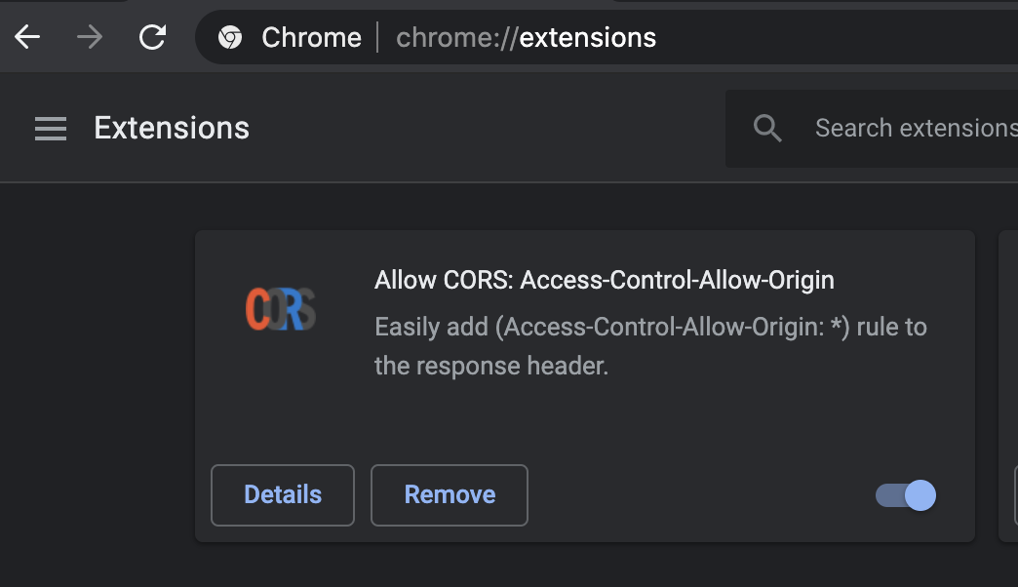

* Once the addon is installed and enabled, open the ‘[FashionGAN.html](https://github.com/Doraiswamy/GAN-fashion-set-generator/blob/master/SystemCode/frontend/FashionGAN.html)’ page which is present under the folder [SystemCode](https://github.com/Doraiswamy/GAN-fashion-set-generator/tree/master/SystemCode) > frontend.
* Once the page is open, please follow the user guide below that showcases the various options available along with corresponding screenshots.

USER GUIDE

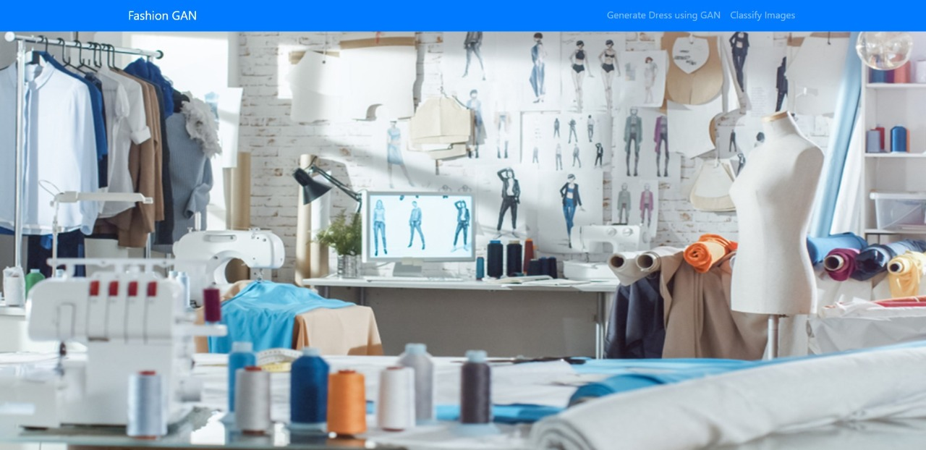

* The above screenshot represents the homepage of Fashion GAN. There are a couple of buttons, Generate Dress using GAN and Classify Images, available on the page.
* Click on ‘Generate Dress using GAN’ button.

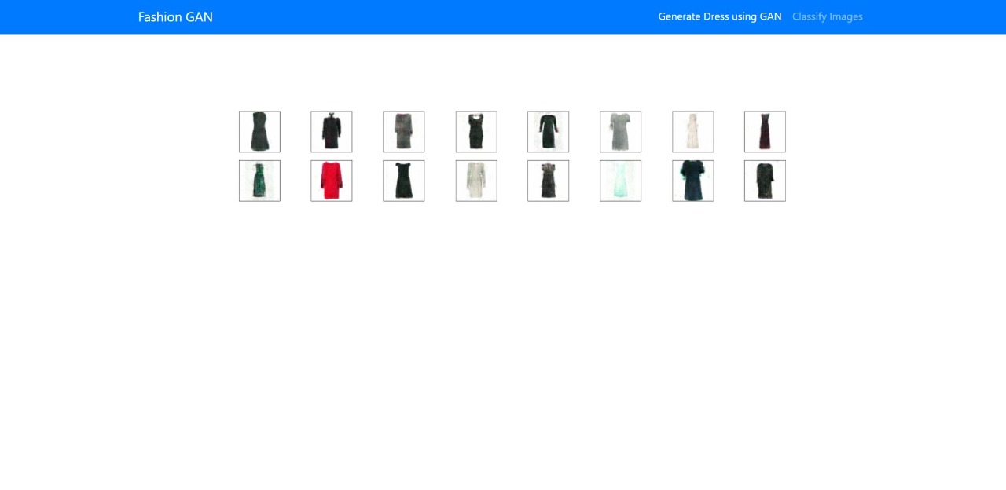

* The above screenshot reflects a set of fashion clothing that are generated by DCGAN (in the backend). These clothing images are generated afresh by GAN and are not part of the dataset it was trained on.
* Now click on ‘Classify Images’ button. This would direct you to the page as shown below.

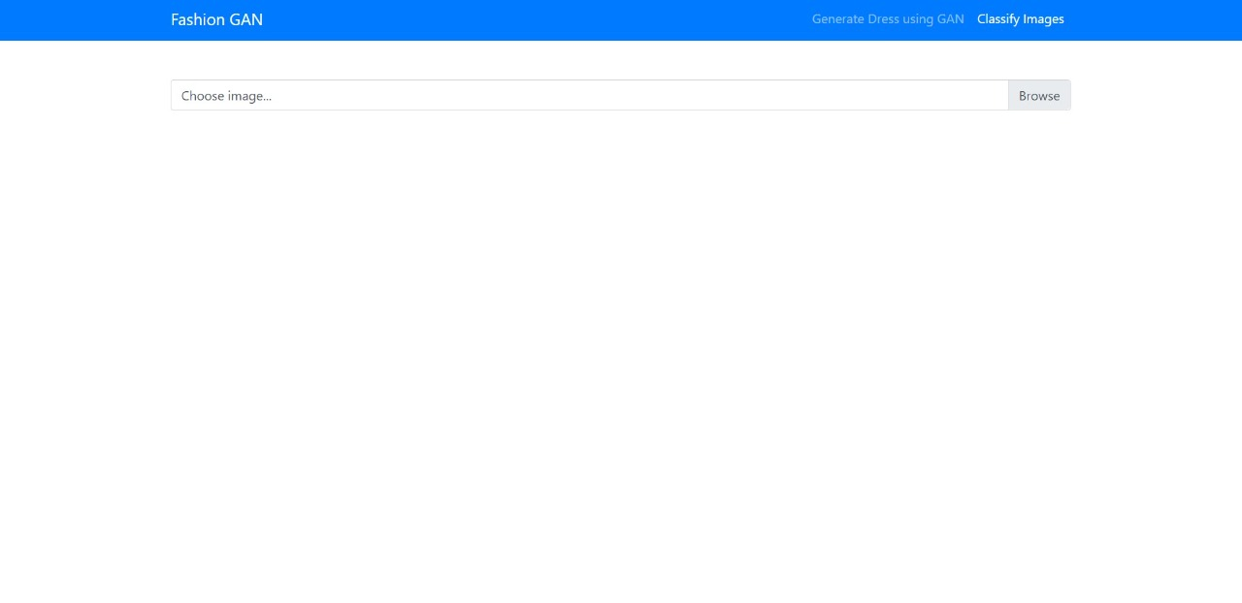

* Here, you can upload image of women clothing (refer the next section that has information on what pattern types are supported).
* The classifier in the backend would then predict the pattern of the image along with it’s sleeve length, dress length, neckline and color. The screenshot below depicts the same.

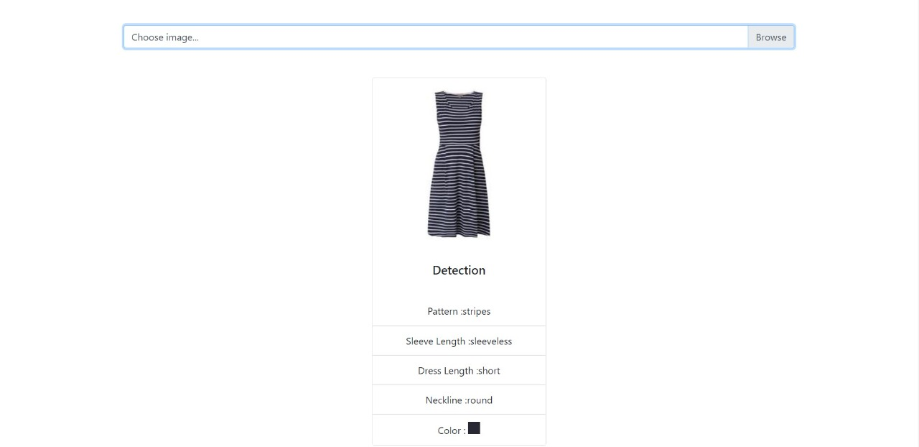

Guideline to Upload Images for Classification :

* Make sure that the woman clothing image that you are uploading belongs to one of the following six pattern types: floral, lace, polkadots, print, stripes, unicolors.
* Make sure that the images being uploaded are of resolution 256 x 256 for optimum results.